

**COMSATS University Islamabad,   
Abbottabad Campus**

**Project Proposal   
(SCOPE DOCUMENT)**

**For**

**ROBUST CAR MODIFICATION SIMULATION SYSTEM USING AI**   
Version 1.0

***By***

**BASIT IQBAL CIIT/FA21-BSE-050/ATD**

**FATIMA AFTAB CIIT/FA21-BSE-088/ATD**

**SYED SHAH HUSSAIN CIIT/FA21-BSE-172/ATD**

**Supervisor**

**Dr. Ahmed Saeed Khattak**

***Bachelor of Science in Software Engineering (2021-2025)***

|  |  |  |
| --- | --- | --- |
| **No.** | **Comment** | **Action** |
|  |  |  |
|  |  |  |
|  |  |  |
|  |  |  |
|  |  |  |
|  |  |  |

**SCOPE DOCUMENT REVSION HISTORY**

**Supervisor Signature**

**Date:**

**Table of Contents**

**ABSTRACT** 6

**1.** **INTRODUCTION** 7

**2.** **PROBLEM STATEMENT** 8

**3.** **PROBLEM SOLUTION FOR PROPOSED SYSTEM** 9

**4.** **RELATED SYSTEM ANALYSIS/LITERATURE REVIEW** 10

5.1. Image-Based Customization 11

5.2. Advanced Part Recognition and Overlay 11

5.3. Improved Customer Satisfaction 11

5.4. Enhanced Decision-Making 11

5.5. Increased Accessibility and Adaptability 11

5.6. Efficient and Cost-Effective Customization 11

5.7. User-Friendly Experience 12

**6.** **SCOPE** 13

**7.** **MODULES** 14

7.1. Image Capture and Upload Module 14

7.2. AI-Driven Part Detection and Segmentation Module 14

7.3. Stitching of the Detected parts 14

7.4. Modification Library and Database Module 14

7.5. Customization Module 14

7.6. Reporting Module 15

7.7. User Management Module 15

7.8. Administration and Configuration Module 15

7.9. Data Security and Privacy Module 15

**8.** **SYSTEM LIMITATIONS/CONSTRAINTS** 16

8.1. Dependency on Camera Quality 16

8.2. Scope Limited to External Modifications 16

8.3. Hardware Compatibility Issues 16

8.4. Incomplete Vehicle Model Support 16

8.5. Requirement for Stable Internet Connectivity 16

8.6. Requirement for Stable Internet Connectivity 16

8.7. Dependence on AI Model Accuracy 16

**9.** **SOFTWARE PROCESS METHODOLOGY** 17

9.1. Iterative Development 17

9.2. Incremental Progression 17

**10.** **TOOLS AND TECHNOLOGIES** 18

**11.** **PROJECT STAKEHOLDERS AND ROLES** 19

**12.** **TEAM MEMBERS INDIVIDUAL WORK DIVISION** 20

**13.** **DATA GATHERING APPROACH** 21

13.1. Local Car and Modification Shops 21

13.2. E-commerce Websites 21

13.3. Public Datasets from Kaggle 21

13.4. Google Images 21

13.5. Dataset Links: 21

13.5.1. Dataset for headlights 21

13.5.2. *3291* labeled images of car’s parts 21

**14.** **CONCEPTS** 22

14.1. Computer Vision 22

14.2. Machine Learning for Part Recognition 22

14.3. Image Segmentation 22

14.4. Data Management and Catalog Integration 22

14.5. User Experience (UX) Design in Customization Tools 22

**15.** **GANTT CHART** 23

**16.** **MOCKUPS** 25

**17.** **CONCLUSION** 29

**18.** **REFERENCES** 29

**Figures:**

*Figure 1:Gantt Chart Table* 23

*Figure 2:Gantt Chart* 24

*Figure 3:Operator's Dashboard* 25

*Figure 4:Car model selection screen* 26

*Figure 5:Modification part selection screen* 27

*Figure 6:Modification screen* 28

**Tables:**

*Table 1:Problems and their solutions for Proposed Solution* 9

*Table 2: Related Systems' similarity, weakness and solution* 10

*Table 3:Tools and Technologies* 18

*Table 4:Project Stakeholders and Roles* 19

*Table 5:Team members work division* 20

**Project Category: (**Select all the major domains of proposed project**)**

* **A-**Desktop Application/Information System **B-**Web Application/Web Application based Information System **C-** Problem Solving and Artificial Intelligence ** D-**Simulation and Modelling ** E-** Smartphone Application ** F-** Smartphone Game ** G-** Networks ** H-** Image Processing****Other (specify category) ______________________

# **ABSTRACT**

The RCMS (Robust Car Modification Simulation) System Using AI is a cutting-edge solution and an innovative answer to the question of void that exists between the customer’s imagination and their actual lives at the modification centers. This system is designed to enhance the car modification experience through precise and accurate image-based visualization. Car enthusiasts and customers often struggle to accurately envision modifications, leading to a problem of mismatch between the outcome and their imagination, which intern leads to dissatisfaction and increased costs. So, to close this gap, a system that provides a high-quality preview is vital.

While existing solutions do provide basic customization options, they lack precision when it comes to displaying or visualizing modifications on images of cars or automobiles. Well catalogues and static images are used frequently used, but they frequently fail to provide realistic preview and adaptable modifications tailored to a specific car model, limiting user confidence in modification choices. The proposed system uses AI (Artificial Intelligence), CV (Computer Vision) to deliver high-fidelity, realistic previews of modifications on image of cars, enabling users to see accurate visualizations before making any decisions.

By improving the accuracy and precision of modification previews and offering an engaging, user-friendly experience, this system levitates customer satisfaction and decision-making, making car customization more rewarding and satisfactory.

# **INTRODUCTION**

The automotive modification industry has experienced explosive growth as car enthusiasts and consumers seek to personalize their vehicles. Yet, a significant obstacle or a major challenge persists: the lack of effective tools for visualizing modifications before they are applied. To get a sense of modifications like rims, spoilers, and paint changes, car owners have traditionally relied on static images and catalogues which often fell short on providing an accurate representation. This gap leads to customer dissatisfaction, and diminished trust in modification services.

The RCMS addresses this issue by leveraging advanced AI techniques, including segmentation, and detection. In Contrast of real-time systems, this solution processes images captured of the vehicle, enabling precise overlay and replacement of parts like rims, headlights, or paint color directly on the image. Through this approach, users receive realistic previews of modifications tailored to the minute details of their vehicle, enabling and empowering more confident decision-making.

At the core of this system are powerful AI algorithms that accurately identify and segment car parts within images, allowing modifications to be rendered with high fidelity. Additionally, this system also incorporates a comprehensive user management feature, enabling users to save their modification choices, revisit preferences, and easily navigate the catalog of customization options.

By facilitating customers with realistic previews of their desired car modifications, the System enhances customization experience, helping customers make more informed decisions while building trust with service providers. This proposal outlines the system’s framework, its components for image-based modification simulation, and its impact on improving customer experience in automotive customization shops.

# **PROBLEM STATEMENT**

The Robust Car Modification Simulation System Using AI is an innovative and a crucial solution in the automotive modification industry, where car enthusiasts and customers frequently struggle to visualize modifications on their specific vehicles. While existing garages or modification centers often use catalogs with static images to guide customers, these tools often fall short of providing accurate, model-specific previews. This visualization gap can lead to frustration and disappointment, as customers are left unsure of how modifications like paint colors, rims, or body kits will appear on their car or vehicle. In an era where vehicle personalization is an expression of individuality, there is a growing need for a sophisticated tool offering realistic, image-based visualizations. This software enables users to explore modifications directly on a digital representation of their vehicle, making informed choices before committing to any physical changes.

Although some existing applications do support basic vehicle customization, they lack the precision, adaptability, and user-friendliness that modern consumers expect. The (RCMS) Robust Car Modification Simulation System addresses these limitations by providing enhanced user experience designed to increase customer satisfaction. Developing this system provides an opportunity to engage deeply with advanced and cutting-edge technologies like AI, computer vision, and machine learning, focusing on parts detection, segmentation, and part replacement.

Additionally, this project will refine my skills across the software development lifecycle—from creatin intuitive user interfaces to implementing complex algorithms for car part detection and customization. By effectively managing user data and efficiently optimizing system responsiveness, we aim to create a seamless and an engaging experience for users. Ultimately, the RCMS (Robust Car Modification Simulation) System Using AI is more than just a project; its n answer to a vital question and a solution to a pressing issue in the automotive market, equipping us with the technical expertise essential for a career in software development and the automotive industry. By bridging the gap between customer expectations and real-world results, this software has the potential to transform vehicle personalization, making it a more satisfying and accessible experience.

# **PROBLEM SOLUTION FOR PROPOSED SYSTEM**

The RCMS System addresses critical challenges in the automotive modification industry by presenting a solution that allows customers to visualize modifications accurately on digital images of their specific vehicles. Traditional catalog images, though commonly used in garages and modification centers, often fail to provide a realistic, vehicle-specific preview. This solution leverages AI-driven part recognition, segmentation and customization overlay to provide users with high-quality, adaptable visualizations tailored to their unique car models and modification choices. Through a user-friendly interface, customers can explore and personalize modifications with greater confidence, ensuring that the result aligns with their vision.

Below is a summary table highlighting the core problems and corresponding solutions that the Robust Car Modification Simulation System aims to address:

*Table 1:Problems and their solutions for Proposed Solution*

|  |  |
| --- | --- |
| **Problems** | **Solutions** |
| Customers often struggle to visualize modifications accurately on their specific vehicles. | The system provides realistic, high-fidelity previews of modifications on images of individual vehicles, helping users visualize changes with greater confidence. |
| Static images and catalogues lack adaptability for different car models and customization needs. | Using AI-based image recognition and segmentation, the system customizes visualizations for a range of vehicle models, offering tailored previews that adapt to unique car specifications. |
| Customers face dissatisfaction due to inaccurate modification previews from traditional catalogues. | Advanced AI enables accurate part detection and overlay, allowing users to preview modifications (like rims, paint colour, spoilers) with greater precision and alignment to their car model. |
| Limited user engagement and confidence in modification choices. | The system’s interactive interface allows users to explore and save their modification preferences, making the process more engaging and reducing hesitation in decision-making. |

# **RELATED SYSTEM ANALYSIS/LITERATURE REVIEW**

*Table 2: Related Systems' similarity, weakness and solution*

|  |  |  |  |
| --- | --- | --- | --- |
| **Application Name** | **Similarity** | **Weakness** | **Solution** |
| 3D Tuning | Provides 3D customization options, allowing users to modify various car parts and view them in 3D | Requires high-quality 3D models and lacks adaptability for all car models; limited by model availability | The Robust Car Modification Simulation System uses 2D image-based customization with AI-driven part detection, allowing accurate overlays on diverse vehicle images without requiring 3D models. |
| AR Car (Android APP) | Uses augmented reality to apply basic modifications, allowing users to visualize parts on their car through a mobile camera feed | Relies on real-time AR, requiring high-quality camera feeds; lacks model-specific customization accuracy and can have limited part options | The system provides static image-based modifications, allowing Modification centres to use accessible image uploads with AI-driven segmentation, ensuring realistic previews without real-time AR limitations. |
| Interactive Garage | Offers customization with a catalogue of parts for different car models, including paint and accessory options | Limited customization options; lacks realistic overlays and specific placement of modifications on car images | This system uses AI-powered detection and part segmentation for precise modification placement, providing realistic previews tailored to customer-selected parts and accurate overlay on car images. |

1. **ADVANTAGES/BENEFITS OF PROPOSED SYSTEM**

## **Image-Based Customization**

Unlike traditional catalog or basic configurator tools, this system provides realistic, image-based previews of car modifications, allowing customers to view modifications accurately on their specific vehicle models.

## **Advanced Part Recognition and Overlay**

Leveraging AI-driven detection, the system precisely identifies car parts in images and overlays modifications accurately, ensuring a realistic representation of changes like rims, paint colors, and body kits.

## **Improved Customer Satisfaction**

By offering a clear, detailed visualization of modifications, the system reduces the risk of customer dissatisfaction, helping customers feel confident in their choices before any physical modifications are made.

## **Enhanced Decision-Making**

This tool empowers users to explore various customization options, such as paint colors, rims, and spoilers, on their vehicle's image, enabling well-informed decisions based on accurate visualizations.

## **Increased Accessibility and Adaptability**

Designed to work with standard image inputs rather than high-end cameras or 3D models, this system is accessible for a broad audience, from casual car enthusiasts to professional modification shops.

## **Efficient and Cost-Effective Customization**

By allowing customers to see realistic previews beforehand, the system minimizes the need for costly revisions or returns, saving both time and resources for customers and service providers alike.

## **User-Friendly Experience**

With an intuitive interface, users can navigate easily through options, compare modifications side-by-side, and save their favorite choices, providing an engaging experience that supports repeat use.

# **SCOPE**

The Robust Car Modification Simulation System Using AI is a web-based application tailored specifically for Modification centers, offering customers high-quality and realistic, image-based previews of potential vehicle modifications. Focusing exclusively on external modifications (rims, spoilers, paint, headlights, side mirror shell) the system uses AI-driven part detection and segmentation to overlay modifications accurately on vehicle images. Modification centres can upload display vehicle images and leverage a comprehensive catalogue of customizable options, providing a visually impressive, cost-effective solution that enhances customer engagement. By enabling customers to explore modifications interactively, the system boosts satisfaction and confidence in their choices.

The things which we are not doing are:

Not Real-Time Video Feedback Modification, Exclude Interior Modification, No High-end Hardware, No Complex 3D modeling, Avoid Standalone installation, No custom modification outside catalogue.

# **MODULES**

The RCMS System consists of integrated modules, each of which is designed and developed to ensure seamless user-friendly experience for customers in automotive Modification centers. These modules work together to provide high-quality image-based, realistic visualization of vehicle modifications, confirming and ensuring customer satisfaction and confidence in making decisions about their choices.

## Image Capture and Upload Module

This module allows modification point staff to upload high-quality images of a vehicle to the system. By capturing vehicle images at specific angles or sides, the module ensures precise and accurate placement of modifications on the car image, providing a rock hard, solid foundation for realistic visualizations.

## AI-Driven Part Detection and Segmentation Module

This module is the heart of all the suit or system that uses computer vision and AI algorithms to detect and segment vehicle parts within the uploaded/captured images. Key components, such as rims, headlights, and side mirrors, are identified, allowing precise and accurate overlays of selected modifications on the correct parts. This module ensures that the modifications appear natural and proportionate to the vehicle.

## Stitching of the Detected parts

This module ensures that after we have successfully detected and segmented car parts, each part is precisely mapped for accurate positioning. Once segmentation is complete, key points or edges of the parts are identified, allowing for precise stitching, which replaces existing parts with selected modifications. This stitching process accurately overlays new components—such as rims or spoilers—onto the car image, ensuring realistic and accurate alignment and integration with the vehicle's original structure.

## Modification Library and Database Module

The Modification Library is a catalog of customizable options, including rims, spoilers, paint colors, and other external enhancements. This database is regularly updated with popular and trending modifications, allowing Modification centers to showcase a wide variety of customization options and ensuring the system remains current and relevant to customer demands.

## Customization Module

With an interactive interface, this module enables customers to select and apply modifications to the vehicle image, with instant visual feedback. Customers can explore various customization options, view modifications side-by-side for comparison, and adjust attributes like colour or size where applicable. This module is essential for providing a user-friendly and engaging experience that encourages exploration and personalization.

## Reporting Module

The system collects user feedback on popular modifications and customer preferences, generating insights for Modification centers to better understand customer demands and tailor their offerings. This data is also valuable for future system enhancements, ensuring the application evolves to meet customer expectations and showroom requirements.

## User Management Module

This module manages user accounts for showroom staff and customers, allowing personalized experiences and the ability to save preferred modification choices. For repeat customers or clients with specific preferences, this module enhances the experience by providing access to saved configurations, fostering customer loyalty and encouraging repeat visits.

## Administration and Configuration Module

This module provides Modification centers with administrative controls to manage the application settings, such as updating the modification library, setting customization options, and viewing analytics on popular modifications. It allows Modification centers to have control over the system’s customization options, keeping the content relevant to their brand and customer base.

## Data Security and Privacy Module

As the system involves user data, this module ensures secure handling of customer information, complying with data protection regulations. It maintains the confidentiality of customer preferences and interaction data, providing peace of mind to both showroom staff and customers regarding their data privacy.

Each of these modules plays a critical role in creating an interactive and reliable modification simulation experience in Modification centers, allowing customers to confidently visualize customizations that align with their vision and preferences.

# **SYSTEM LIMITATIONS/CONSTRAINTS**

## Dependency on Camera Quality

The speed or performance of the System is significantly affected by the camera's quality and resolution. Low-resolution cameras can lead to inadequate image detection and rendering, compromising the user experience and the accuracy of the modifications displayed on the vehicle.

## Scope Limited to External Modifications

The initial version of the RCMS system will focus exclusively on external modifications, such as rims, spoilers, and paint colors. This limitation means that interior modifications will not be available, potentially restricting the comprehensive customization options that users may desire.

## Hardware Compatibility Issues

The effectiveness of the system may vary based on the hardware specifications of the devices used in car modification shops. Older devices with limited processing power or outdated graphics capabilities may struggle with real-time rendering and AI processing, resulting in delays or inaccuracies in the displayed modifications.

## Incomplete Vehicle Model Support

While the system aims to accommodate a wide variety of car models, it may not accurately detect or render modifications for less common or vintage vehicles. This limitation could restrict the system's applicability, leading to dissatisfaction among users with specific vehicle types.

## Requirement for Stable Internet Connectivity

As a web-based application, the RCMS system using Ai necessitates a stable internet connection to function optimally. Users located in areas with unreliable internet service may experience interruptions or slow loading times, hindering their ability to utilize the system effectively and efficiently.

## Requirement for Stable Internet Connectivity

As a web-based application, the system requires a stable internet connection to function efficiently. In locations with poor connectivity, users may experience delays or interruptions, affecting the user experience in the showroom setting.

## Dependence on AI Model Accuracy

The system’s effectiveness relies on the precision of AI algorithms for part detection and segmentation. Errors in detection or overlay placement could affect the realism and accuracy of the visualized modifications, potentially leading to customer dissatisfaction.

# **SOFTWARE PROCESS METHODOLOGY**

The Methodology that we will be adapting to develop the RCMS System Using AI is “***Iterative and Incremental Model”***. This methodology is ideal and best suited for handling complex requirements like AI-driven image processing and part segmentation, as it allows the system to evolve and go through successive refinements.

## **Iterative Development**

In each iteration, a part or a unit of the system is developed, tested, and refined. This approach enables continuous improvement, allowing the development team to adjust and upgrade each feature before moving forward. For example, the initial iteration may focus on the basic user interface and image upload functionality, while subsequent iterations add more advanced and complex modules like AI-based part detection and segmentation after proper testing.

## **Incremental Progression**

By building the system incrementally, each completed module/feature is tested and integrated into the overall application, creating a more stable foundation for the upcoming increment. This reduces risk by allowing early testing and validation of core functionalities, ensuring that each module/feature meets customer needs and requirements as it is developed.

# **TOOLS AND TECHNOLOGIES**

*Table 3:Tools and Technologies*

|  |  |  |  |
| --- | --- | --- | --- |
| **Tools And Technologies** | **Tools** | **Version** | **Rationale** |
| **Documentation/Design** | Microsoft Word | 2021 | Documentation |
|  | Google Docs | - | Collaborative Work on Document |
|  | Microsoft PowerPoint | 2021 | Presentation |
|  | Excel | - | Project Management |
|  | StarUML | 5.0 | Diagrams |
|  | Figma | - | UI/UX Design |
|  | Canva | - | Graphic Design + Presentation |
| **MERN Stack** | MongoDB | 6.0 | Database Management System (DBMS) |
|  | Express.js | 4.19.1 | Web Application Framework |
|  | ReactJS | 18.2 | Frontend Framework |
|  | Node.js | 21.0 | Backend Runtime Environment |
| **AI/ML Technologies** | OpenCV | 4.5.5 | Computer Vision Library |
|  | Scikit Learn |  | Open-Source ML Library |
|  | YOLO (You Only Look Once) | - | Object Detection |
|  | SAM (Segment Anything Model) | - | Image Segmentation |
|  | TensorFlow/Keras | 2.12 | AI and Machine Learning Framework |
|  | Hugging Face | - | NLP and Model Deployment Platform |
| **Deployment Tools** | Docker | 24.0 | Containerization |
|  | Streamlit | 1.27 | Interactive Web App Framework for ML |
| **Version Control** | Git | 2.41 | Version Control |
|  | Postman | 10.14 | API Testing and Documentation |
| **Cloud Based Editor & GPU Provider** | Google Collab | - | Cloud-Based Python Development |

# **PROJECT STAKEHOLDERS AND ROLES**

*Table 4:Project Stakeholders and Roles*

|  |  |
| --- | --- |
| **Project Sponsor** | COMSATS University, Islamabad |
| **Stakeholder** | * Students Names: Basit Iqbal, Fatima Aftab, Syed Shah Hussain * Project Supervisor Name: Dr. Ahmed Saeed Khattak * Final Year Project Committee: Evaluation of project |

# **TEAM MEMBERS INDIVIDUAL WORK DIVISION**

*Table 5:Team members work division*

|  |  |  |
| --- | --- | --- |
| **Student Name** | **Student Registration Number** | **Responsibility/ Modules** |
| BASIT IQBAL | FA21-BSE-050 | Basit Iqbal (Module2-Module3)   * Module 2: Ai driven part detection and segmentation * Module 3: Stitching of detected parts |
| FATIMA AFTAB | FA21-BSE-088 | Fatima Aftab (Module 4-Module 6)   * Module 4: Modification library and database * Module 5: Customization Module * Module 6: Reporting Module |
| SYED SHAH HUSSAIN | FA21-BSE-172 | Hussain (Module 1, Module 7- Module 9)   * Module 1: Image capture and upload task * Module 7: User Management * Module 8: Administration and configuration * Module 9: Data Security and Privacy |

# 

# **DATA GATHERING APPROACH**

To ensure the RCMS System delivers accurate and realistic car modification visualizations, we are employing the following data-gathering strategies:

## Local Car and Modification Shops

Focusing initially on Toyota models (XLI, GLI, and Grande from 2009 to 2018), we will collaborate with local car modification shops to collect detailed information on genuine and modified parts. This data will include images, specifications, and measurements for various components like rims, spoilers, headlights, and paint colors, providing a strong foundation for model-specific customization.

## E-commerce Websites

To expand our dataset, we plan to download data from e-commerce platforms that sell car parts. This approach allows us to access a wide variety of parts, both genuine and aftermarket, offering our system a comprehensive catalog for simulation purposes.

## Public Datasets from Kaggle

Kaggle hosts several automotive-related datasets that cover a broad range of car models and parts. By utilizing Kaggle’s car and car parts datasets, we can supplement our data with diverse sources of information, enhancing our model’s robustness and adaptability.

## Google Images

To capture a broader visual dataset, we will gather images from Google Images, focusing on high-quality images of specific Toyota models and modifications. This will provide additional training data for our computer vision models, supporting accurate part recognition and segmentation.

## Dataset Links:

### Dataset for headlights

<https://www.kaggle.com/datasets/hamedahangari/internal-and-external-parts-of-cars>

### *3291* labeled images of car’s parts

<https://universe.roboflow.com/project-p5nyc/car-parts-o7dlr>

# **CONCEPTS**

## Computer Vision

Computer vision is essential for identifying and segmenting car parts in uploaded images, allowing accurate detection of components such as rims, headlights, and side mirrors. In this project, computer vision techniques enable realistic overlays of modifications, enhancing the visualization accuracy for customers in automotive showrooms.

## Machine Learning for Part Recognition

Machine learning models will be trained to recognize various car parts and accurately segment them within an image. This concept helps ensure that modifications are applied precisely, with the model continually learning from data to improve recognition accuracy and support a broader range of vehicle types.

## Image Segmentation

Image segmentation divides an image into segments to isolate specific parts of the car, making it possible to apply modifications only to targeted areas. This concept is crucial for placing modifications like new rims or paint color changes in a way that aligns realistically with the car's actual structure.

## Data Management and Catalog Integration

Effective data management enables the creation of a robust catalog of customizable options, such as rims and paint colors, that customers can choose from. This concept involves organizing, updating, and handling catalog data to ensure that modification options remain current and relevant for showroom users.

## User Experience (UX) Design in Customization Tools

UX design principles are applied to create a smooth and intuitive interface, allowing customers to easily explore and select modifications. This concept is central to developing a user-friendly customization tool, where effective design enhances customer engagement and satisfaction in the modification selection process.

# **GANTT CHART**

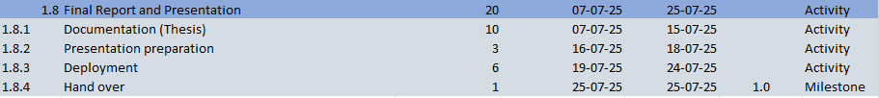

*Figure 1:Gantt Chart Table*

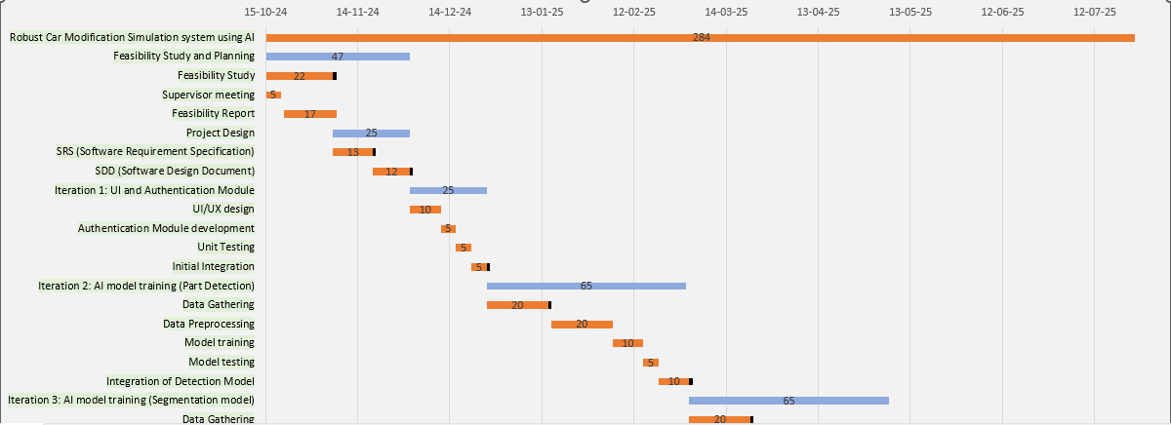

*Figure 2:Gantt Chart*

# **MOCKUPS**

*Figure 3:Operator's Dashboard*

*Figure 4:Car model selection screen*

*Figure 5:Modification part selection screen*

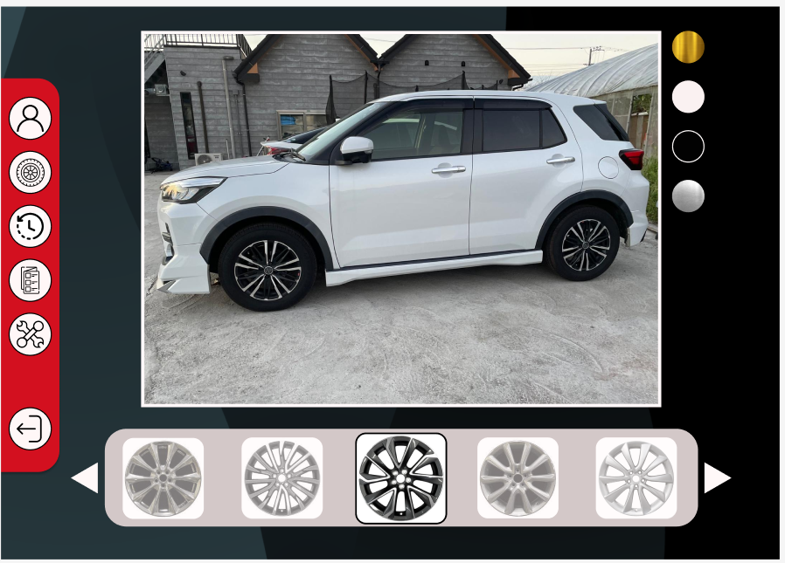

*Figure 6:Modification screen*

# **CONCLUSION**

The **Robust Car Modification Simulation System Using AI** is a web-based tool tailored for automotive showrooms, enabling customers to view realistic, image-based previews of vehicle modifications like rims and paint changes. By leveraging AI for part detection, image segmentation, and overlay accuracy, the system enhances customer engagement and satisfaction with informed, visually accurate customization options. Developed iteratively with a focus on computer vision, machine learning, and UX design, this project aims to transform the showroom experience by providing a streamlined, accessible solution for vehicle personalization.

# **REFERENCES**

* Ultralytics. (2024). *CarParts dataset: Sample data and annotations.* Available at: <https://docs.ultralytics.com/datasets/segment/carparts-seg/#sample-data-and-annotations>
* Docker. (2024). *Docker documentation.* Available at: <https://docs.docker.com/>
* Streamlit. (2024). *Stream lit documentation.* Available at: <https://docs.streamlit.io/>
* Ultralytics. (2024). *SAM model documentation.* Available at: <https://docs.ultralytics.com/models/sam/>